ESP32-CAM video stream and face recognition using Arduino IDE
This article is a quick start guide for ESP32-CAM board. We will show you how to use Arduino IDE to set up a video streaming Web server with facial recognition and detection in less than 5 minutes.
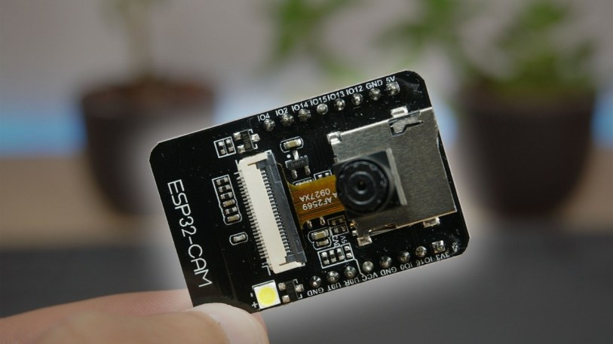
Note: In this tutorial, we use the examples in arduino-esp32 library. This tutorial does not describe how to modify the example.

Part requirements
To learn this tutorial, you need the following components:
- ESP32-CAM with OV2640
- FTDI programmer
- Female-to-female jumper wires

Introducing ESP32-CAM
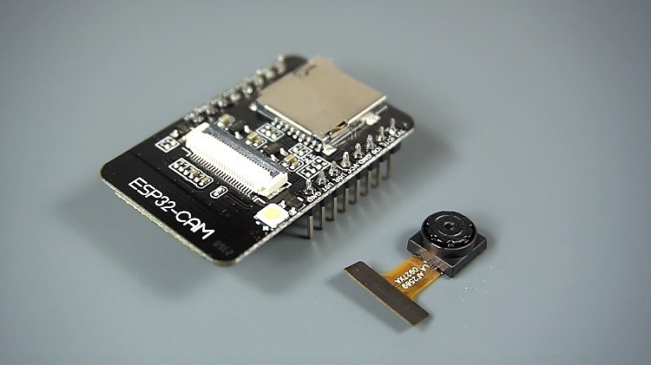
shouldESP32-CAMIt's a very small camera module and the cost of ESP32-S chip is about $10. In addition to OV2640 camera and several GPIO connected to peripheral devices, it also has a microSD card slot, which can be used to store images taken by the camera or files for customers to use.
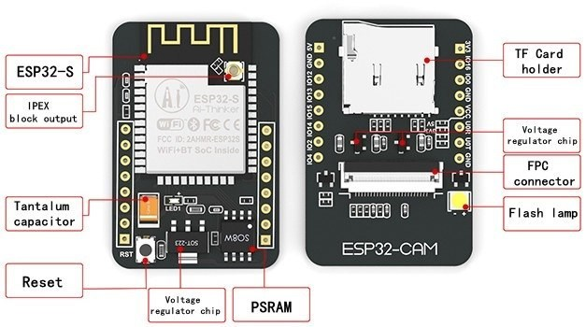
- shouldESP32-CAMThere is no USB interface, so you need an FTDI programmer to upload codes U0R and U0T pins (serial pins).
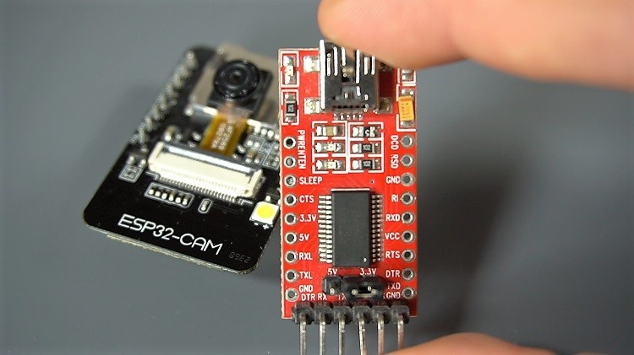

characteristic
The following is a list of ESP32-CAM functions:
- The minimum 802.11b/g/n Wi-Fi BT SoC module
- Low power consumption 32-bit CPU, which can also serve application processors.
- Clock speed is as high as 160MHz, and total calculated power is as high as 600dips.
- Built-in 520 KB SRAM, external 4MPSRAM
- UART/SPI/I2C/PWM/ADC/DAC support
- Support OV2640 and OV7670 cameras with built-in flash
- Support image WiFI upload
- TF card support
- Support multiple sleep modes.
- Embedded Lwip and FreeRTOS
- Operation mode of STA/AP/STA+AP is supported.
- Support Smart Config/AirKiss technology
- Support serial port local and remote firmware upgrade (FOTA)

ESP32-CAM Pinout
The following figure shows the pin arrangement of ESP32-CAM (AI-Thinker module).
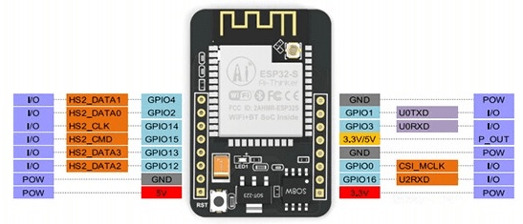Image-Seeed Studio
There are three GND pins and two pins for power supply: 3.3V or 5V.
GPIO 1 and GPIO 3 are serial pins. You need these pins to upload the code to your circuit board. In addition, GPIO 0 also plays an important role because it determines whether the ESP32 is in the flashing mode. ESP32 is in flashing mode when GPIO 0 is connected to GND.
The following pins are internally connected to the microSD card reader:
- GPIO 14：CLK
- GPIO 15：CMD
- GPIO 2: data 0
- GPIO 4: Data 1 (also connected to the onboard LED)
- GPIO 12: data 2
- GPIO 13: data 3

Video streaming server
Follow the steps below to build a video streaming Web server using ESP32-CAM that you can access on your local network.

1. install ESP32 plug-in
In this example, we use Arduino IDE to program the ESP32-CAM board. Therefore, you need to install Arduino IDE and ESP32 plug-in.

2. CameraWebServer sample code
In the Arduino IDE, go to File > Examples > ESP32 > Camera, and then open the CameraWebServer example.
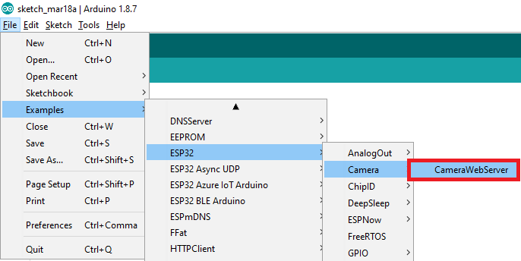
The following code should be loaded.
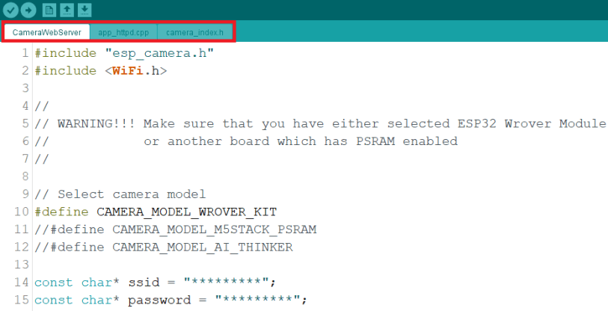
If you can't find the code in Arduino IDE, you canDownload from our GitHub repository. After downloading, unzip the folder, and then open the CameraWebServer.ino file.
Before uploading the code, you need to insert the network credentials in the following variables:
const char* ssid = "REPLACE_WITH_YOUR_SSID";
const char* password = "REPLACE_WITH_YOUR_PASSWORD";

Then, make sure to select the correct camera module. In this case, we use the AI-THINKER model.
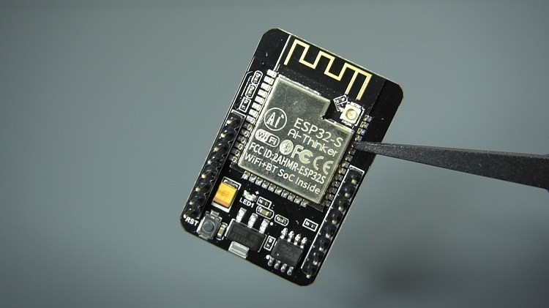
So, comment on all other models and uncomment them:
#define CAMERA_MODEL_AI_THINKER
Now, the code is ready to be uploaded to your ESP32

ESP32-CAM upload code
Use FTDI programmer to connect the ESP32-CAM board to the computer. According to the next schematic diagram:
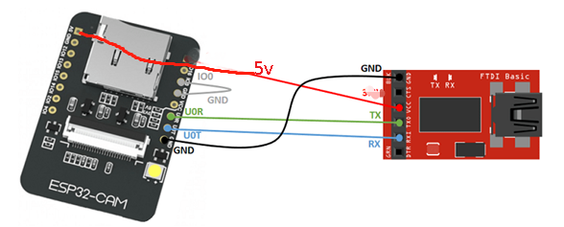
Important: GPIO 0 needs to be connected to GND so that you can upload the code.
To upload the code, please follow these steps:
- Go to tools > board, and then select ESP32 Wrover module.
- Go to tools > ports, and then select the COM port to which the ESP32 is connected.
- In Tools > Partition Scheme, select "Huge APP(3MB without OTA)"
- Press the RESET button on ESP32-CAM.
- Then, click the upload button to upload the code.
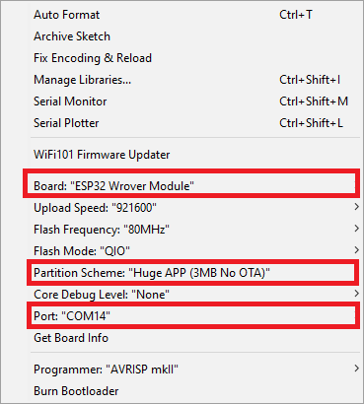
Important: If you can't upload the code, please carefully check whether GPIO 0 is connected to GND and select the correct setting in the Tools menu. You should also press the onboard reset button to restart ESP32 in flashing mode.

Get IP address
After uploading the code, disconnect GPIO 0 from GND.
Turn on the serial monitor at baud rate of 115200. Press the ESP32-CAM on-board reset button.
The ESP32 IP address should be printed in the serial monitor.
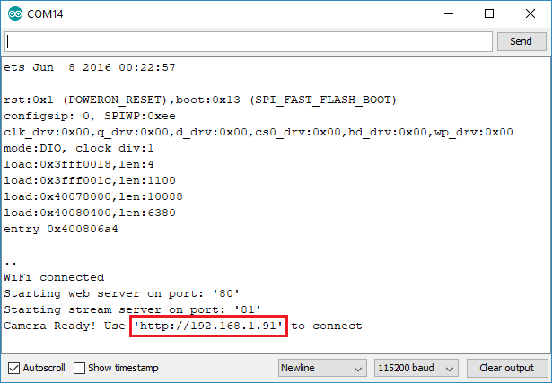

Access the video streaming server
Now, you can access your camera streaming server on your local network. Open a browser and type the IP address of esp 32-cam. Press the Start Streaming button to start video streaming.
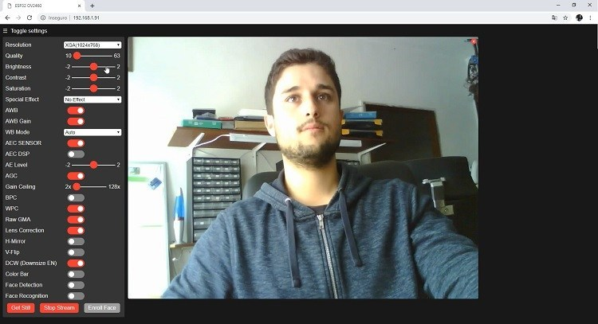
You can also take photos by clicking the "Get Still" button. However, this example cannot save photos, but you can modify it to use the onboard microSD card to store the taken photos.
You can also use a variety of camera settings to adjust the image settings.
Finally, you can perform face recognition and detection.
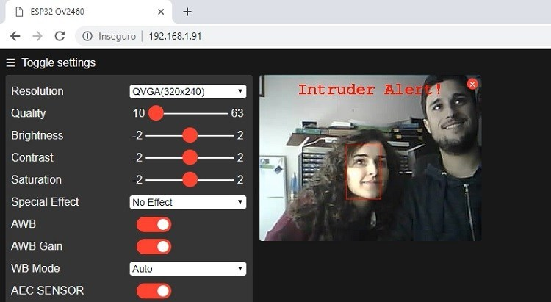
First, you need to register a new face. It will try to recognize faces many times. After registering a new user, it should detect the face (topic 0) later.
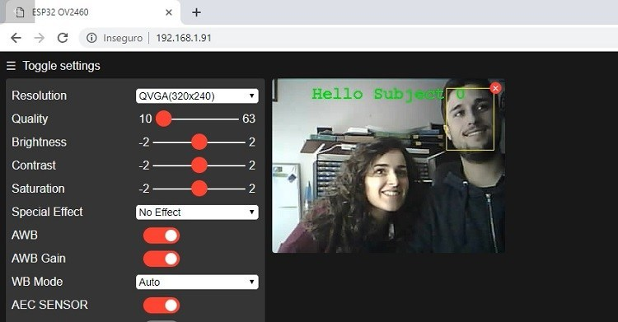
That's it. Now, you can start and run the video streaming Web server with face detection and recognition using the examples in the gallery.
ESP32-CAM provides an inexpensive way to build more advanced home automation projects, including video, photo taking and face recognition.
In this tutorial, we tested the CameraWebServer example to test the camera function. Now, our idea is to modify the example or write a brand new code to build other projects. For example, taking a picture when an action is detected and saving it to a microSD card, integrating video streams in a home automation platform (such as Node-RED or Home Assistant), and so on.

First, the actual effect
This demo demonstrates how to remotely view the video stream shot by ESP32-CAM in real time by using APP based on WAN.
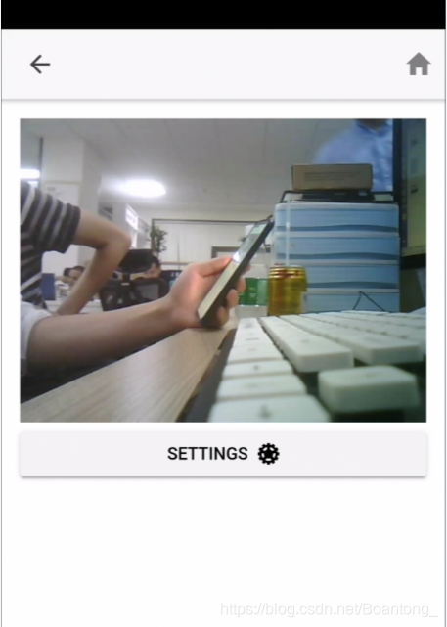
Video streaming effect link: https://pan.baidu.com/s/1mGjPr4TN8lLoEdGe4Tn1Mg
Pick-up code: rrcq

II. Preparations
1.ESP32-CAM development board
2.USB TO TTL and Dubang cable
3.SDK
4. Android APP---- Link: https://pan.baidu.com/s/1ZxIVD3EKzHdn6UchkXcnrw
Pick-up code: n6tp

Third, the development environment construction
It is recommended to develop based on **Linux(ubuntu)** environment, which needs to be understood by you in combination with the official chip building process-"Development environment guide,Get the SDK esp-idf 4.0 of ESP32 in the current directory.
git clone -b release/v4.0 --recursive https://github.com/espressif/esp-idf.git
- 1

Fourth, code understanding mind map
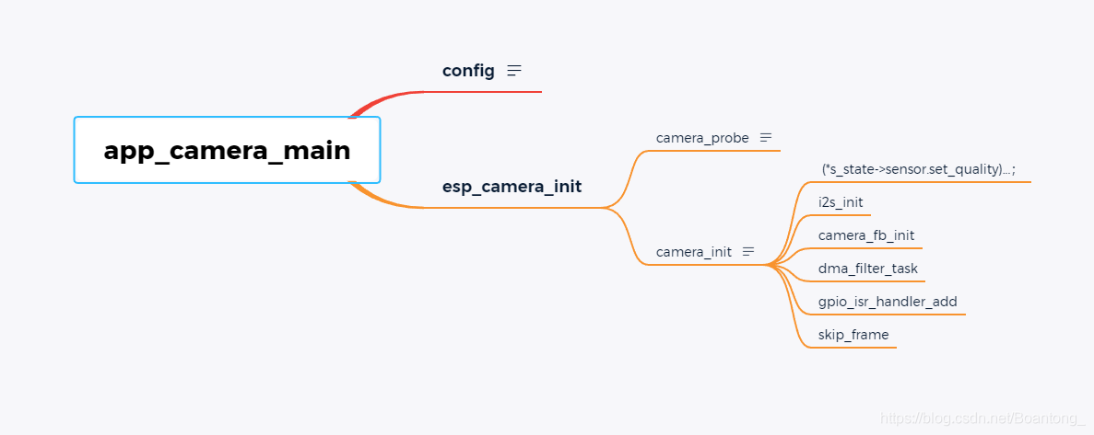

Five, to achieve the effect of the operation process
1. Build a development environment
2. configure make menuconfig: input SSID,PASS and id "asrrmhso.zuzcni.trial.nabto.net", key
"337acb58e15b72117a 49bf779d90cb29", select-> ai.tinker.
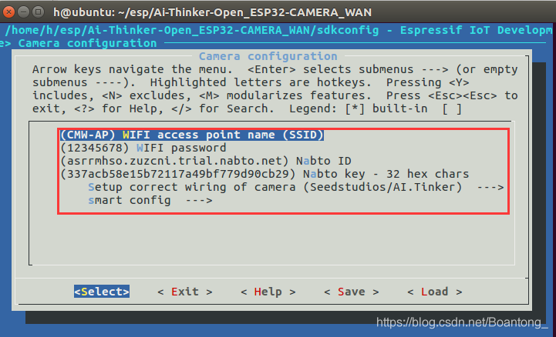
3. Burn make flash(IO0 pin-down) and use ESP-TOUCH for network distribution, and IO0 pin-up is successful.
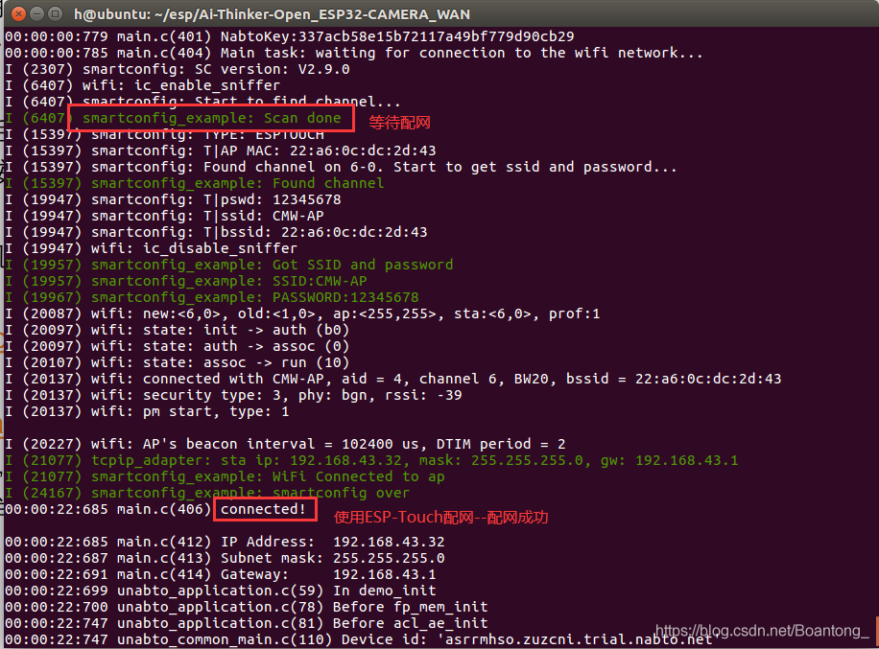
4. Go to the app and select "refresh". If a device is found, click to connect it.
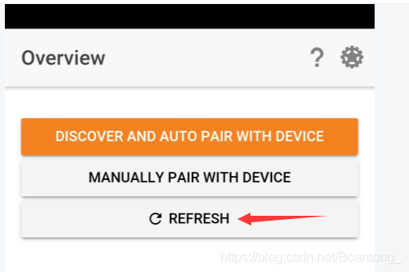
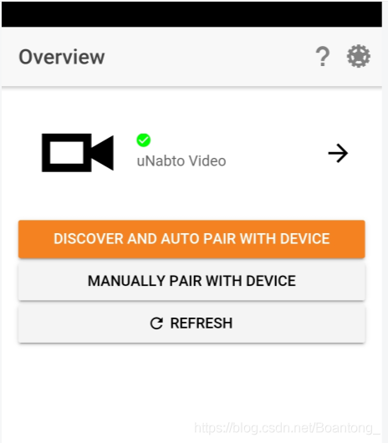

VI. Summary
The ESP32-S module drives the camera OV2640, with a clock frequency of 20mhz. The image format is JPEG, with a resolution of VGA 640*480 and a frame rate.
15 frames /s on average, with an upload rate of 150KB/s~300KB/s (this data is a hot spot for accessing mobile phones, and it is better when the network environment is good);
At the same time, the maximum resolution when taking pictures is 1600*1200; Generally speaking, this demo is still ideal, and there is still a lot of room for optimization.
Leave it to the code friends.

